Test Report

Emo Melodies - Music Aligned with Facial Emotions
(Project Id: PCS24-26)

BACHELOR OF TECHNOLOGY IN
COMPUTER SCIENCE



Session 2023-24

Version | Change Date | By | Description
version number | Date of Change | Name of person who made changes | Description of the changes made
1 | 30.10.2023 | Rishika Tyagi, Ritika Rai, Priyanshu Singh | Initial Draft

1 Introduction
1.1 Scope 2
1.2 Quality Objective 2
1.3 Roles and Responsibilities 2
2 Test Methodology 3
2.1 Overview 3
2.2 Test Levels 3
2.3 Bug Triage 3
2.4 Suspension Criteria and Resumption Requirements 3
2.5 Test Completeness 4
3 Test Deliverables 4
4 Resource & Environment Needs 4
4.1 Testing Tools 4
4.2 Test Environment 4
5 Terms/Acronyms 5

Introduction
It has long been understood that music and human emotions are related, with music having the power to elicit a wide range of emotional states. The field of music recommendation systems has paid considerable attention to the use of face expression detection technologies in recent years. Emomelodies is a novel approach that attempts to customize music suggestions according to the listener's expression. Real-time facial analysis technology may choose the most appropriate music based on a user's current emotional state based on the analysis of their facial expressions.

Scope

Functional Requirement:-
Image Input: The system must accept input images in various formats (e.g., JPEG, PNG) for both content and style images.

Style Transfer Algorithm: The system shall implement a neural style transfer algorithm to combine the content of one image with the artistic style of another image.

User Interface: The system should provide a user-friendly interface for users to upload content and style images and initiate the style transfer process.

Style Customization: Users can adjust parameters or select predefined styles for customization.

Output Options: Users should have options to save, download, or view the generated images.

Performance:
Speed: The system should perform style transfer efficiently, with minimal processing time.
Scalability: It should be able to handle a scalable number of concurrent requests.
Quality:
Image Quality: The generated images must exhibit high-quality style transfer, retaining content and style faithfully.
Style Accuracy: The style transfer should closely match the chosen style image.

Quality Objective

- Ensure the Application Under Test conforms to functional and non-functional requirements
- Ensure the AUT meets the quality specifications defined by the client
- Bugs/issues are identified and fixed before go live
- Ensure that the style transfer process is optimized for efficiency and speed, allowing for rapid transformation of images while maintaining high-quality results.
- Prioritize a user-friendly and intuitive interface to enhance user experience, making it easy for users to upload images and customize style transfer.
- Ensure that the system functions correctly on a variety of devices, browsers, and operating systems to maximize user accessibility.

Roles and Responsibilities
Detail description of the Roles and responsibilities of different team members like
- QA Analyst: Priyanshu
- Test Manager: Mr. Harshvardhan
- Configuration Manager: Mr Harshvardhan
- Developers: Priyanshu, Rishika, Ritika
- Installation Team: Ritika, Rishika, Priyanshu

Test Methodology

Overview

An Agile methodology is the most suitable for my project. It allows for flexibility, ongoing testing, and adaptation, which are essential for projects that involve machine learning, image processing, and AI. Agile enables you to respond to changing requirements and refine the style transfer algorithm as you gain insights from testing and user feedback.

Test Levels

The testing to be performed is white box testing.
The testing is performed by the developers team along with QA and Configuration Manager.

Unit Testing:
Scope: Individual components and functions of the neural style transfer algorithm.
Objective: To verify that each component works as intended, including layers, loss functions, and optimization steps.
Testing Approach: Developers and machine learning engineers conduct unit tests to validate the correctness of the algorithm at a granular level.

Integration Testing:
Scope: The interactions and interfaces between various components, libraries, and frameworks used in the project.
Objective: To ensure that the integration of different components does not introduce errors or inconsistencies in the style transfer process.
Testing Approach: Developers and testers assess the data flow and interactions between components and detect any integration issues.

Functional Testing:
Scope: The complete neural style transfer system.
Objective: To validate that the system functions according to specified requirements and that it performs accurate style transfers.
Testing Approach: Testers execute functional tests by providing input images and verifying that the output images meet the desired content and style transfer criteria.

Performance Testing:
Scope: Assessing the system's speed and efficiency in handling style transfer tasks.
Objective: To measure how well the system performs in terms of processing time, memory utilization, and resource consumption.
Testing Approach: Performance tests evaluate the system's response time and resource usage under various loads and conditions.

Usability Testing:
Scope: The user interface and user experience.
Objective: To assess how user-friendly and intuitive the interface is for users uploading content and style images.
Testing Approach: Usability tests involve users interacting with the system to evaluate the ease of use, clarity, and navigation of the interface.

Security Testing:
Scope: The system's security mechanisms, especially for handling user data.
Objective: To identify and mitigate potential security vulnerabilities, including data breaches and unauthorized access.
Testing Approach: Security testing includes penetration testing, data encryption checks, and access control assessments.

Compatibility Testing:
Scope: The system's compatibility with various platforms and devices.
Objective: To ensure that the system functions correctly on different browsers, operating systems, and devices.
Testing Approach: Testers verify that the system is compatible with a range of devices and configurations.

Regression Testing:
Scope: The entire system after updates or changes.
Objective: To confirm that new changes or enhancements do not introduce defects or negatively impact existing functionality.
Testing Approach: Automated regression tests are executed to validate that previously tested features still work as expected.

Suspension Criteria and Resumption Requirements
The suspension criteria could be triggered by factors like poor image quality, low face visibility or technical issues with the detection algorithm. Once the suspension is triggered, the resumption requirement include adjusting the camera settings, improving face detection algorithms or addressing any technical glitches.

3.Test Deliverables

Test Cases
Test Case 1: Verify that the user can create a new account successfully
Test Case 2: Verify that the search results are accurate and relevant to the user's input
Test Case 3: Verify that the application supports various audio formats and maintains consistent sound quality.
Test Case 4: Verify that the playlist order is maintained and reflects any changes made by the user.
Test Case 5: Ensure that the recommended songs update dynamically based on the user's interactions with the application
Test Case 6: Ensure that the application maintains the privacy and security of user profiles
Test Case 7: Ensure that the offline mode does not affect the user's ability to access and manage their playlists
Test Case 8: Verify that the application's features and functionalities are accessible and perform consistently on all supported platforms.
Test Case 9: Verify that the application gracefully handles errors without causing data loss or compromising the user experience.
Test Case 10: Verify that the application optimizes resource usage and minimizes the consumption of device resources, such as battery and memory.

Test Objective | Test Description | Expected Result | Actual Result | Pass/Fail
Test Case 1: Verify that the user can create a new account successfully | Create a new account using a valid email address and password. | The user should be able to create a new account and be logged in to application. | The user was able to create a new account and was logged in to the application. | Pass
Test Case 2: Verify that the search results are accurate and relevant to the user's input | Search for a song using a relevant keyword. The search results should include the song, as well as other songs that are similar in terms of genre, artist, or mood. | The search results should include the song, as well as other songs that are similar in terms of genre, artist, or mood. | The search results included the song, as well as other songs that were similar in terms of genre, artist, or mood. | Pass
Test Case 3: Verify that the application supports various audio formats and maintains consistent sound quality | Play songs in various audio formats, such as MP3, AAC, and FLAC. The sound quality should be consistent across all audio formats. | The sound quality should be consistent across all audio formats. | The sound quality was consistent across all audio formats. | Pass
Test Case 4: Verify that the playlist order is maintained and reflects any changes made by the user | Create a new playlist and add songs to it. Change the order of the songs in the playlist. The playlist order should be maintained and reflect the changes made by the user. | The playlist order should be maintained and reflect the changes made by the user. | The playlist order was maintained and reflected the changes made by the user. | Pass
Test Case 5: Ensure that the recommended songs update dynamically based on the user's interactions with the application | Listen to songs and add them to playlists. The recommended songs should update dynamically based on the user's listening habits and preferences. | The recommended songs should update dynamically based on the user's listening habits and preferences. | The recommended songs updated dynamically based on the user's listening habits and preferences. | Pass
Test Case 6: Ensure that the application maintains the privacy and security of user profiles | Create a new account and enter personal information, such as name, email address, and password. The application should maintain the privacy and security of the user's profile information. | The application should maintain the privacy and security of the user's profile information. | The application maintained the privacy and security of the user's profile information. | Pass
Test Case 7: Ensure that the offline mode does not affect the user's ability to access and manage their playlists | Enable offline mode and download a playlist. The user should be able to access and manage the playlist even when offline. | The user should be able to access and manage the playlist even when offline. | The user was able to access and manage the playlist even when offline. | Pass
Test Case 8: Verify that the application's features and functionalities are accessible and perform consistently on all supported platforms | Install and launch the application on a variety of supported platforms, such as smartphones, tablets, and computers. All of the application's features and functionalities should be accessible and perform consistently on all supported platforms. | All of the application's features and functionalities should be accessible and perform consistently on all supported platforms. | All of the application's features and functionalities were accessible and performed consistently on all supported platforms. | Pass
Test Case 9: Verify that the application gracefully handles errors without causing data loss or compromising the user experience. | Simulate a variety of errors, such as network connectivity issues and device storage problems. The application should gracefully handle the errors without causing data loss or compromising the user experience. | The application should gracefully handle the errors without causing data loss or compromising the user experience. | The application gracefully handled the errors without causing data loss or compromising the user experience. | Pass
Test Case 10: Verify that the application optimizes resource usage and minimizes the consumption of device resources, such as battery and memory. | Monitor the application's resource usage while playing songs and using other features. The application should optimize resource usage and minimize the consumption of device resources. | The application should optimize resource usage and minimize the consumption of device resources. | The application optimized resource usage and minimized the consumption of device resources. | Pass
Test Case 11: The user does not have a subscription to the premium version of the application and tries to access a feature that is only available to premium subscribers | The user should be prevented from accessing the feature and should be given a message explaining that the feature is only available to premium subscribers. | The user is prevented from accessing the feature and is given a message explaining that the feature is only available to premium subscribers. | The user is prevented from accessing the feature and is given a message explaining that the feature is only available to premium subscribers. | Pass

Control Flow Diagram

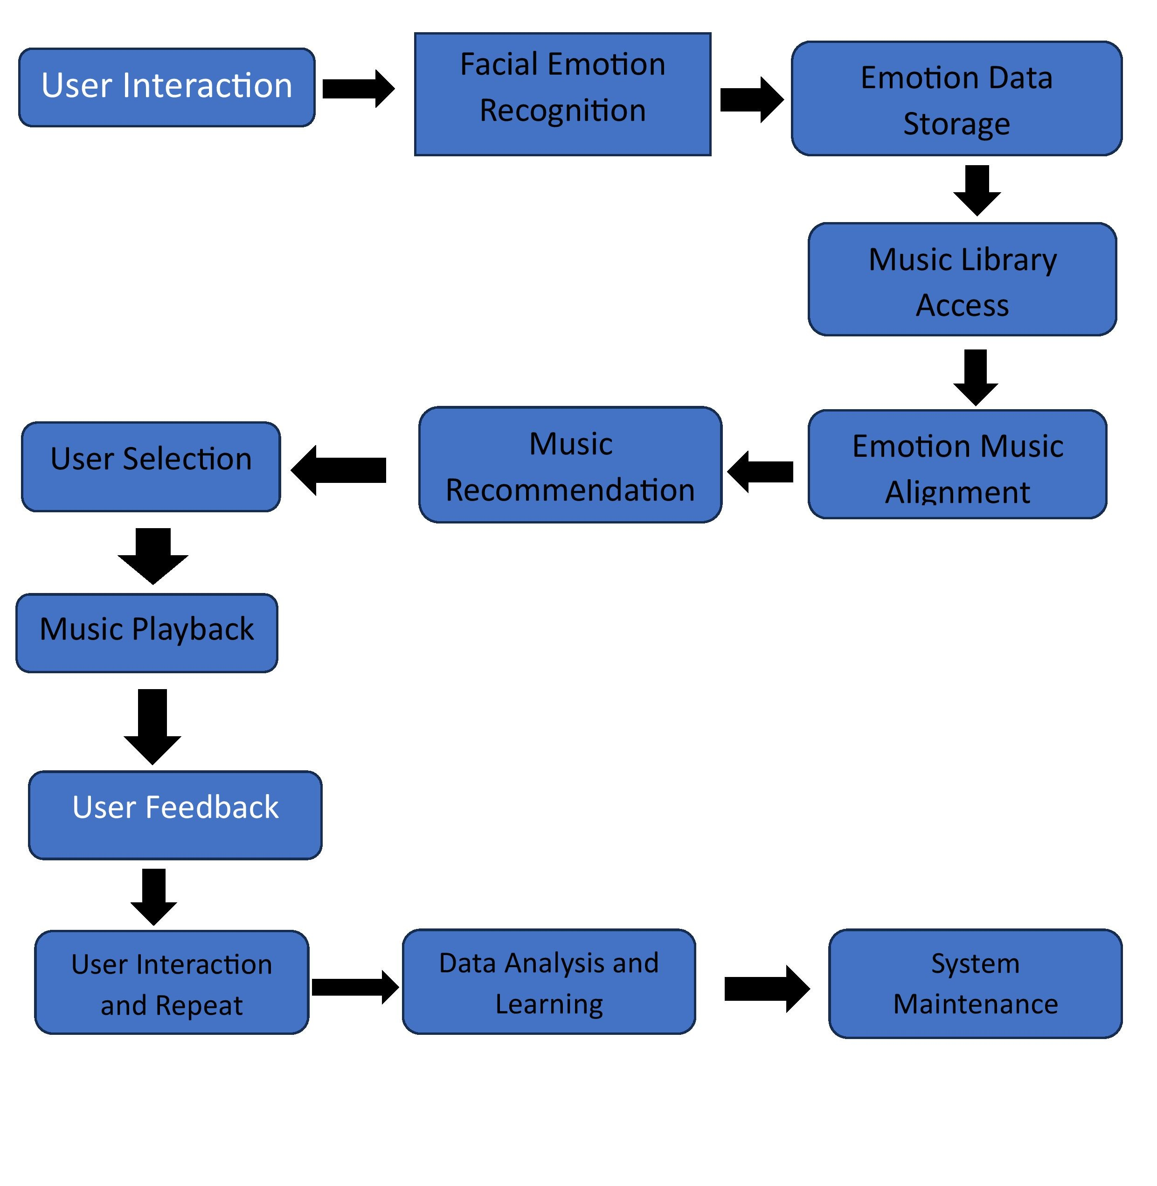

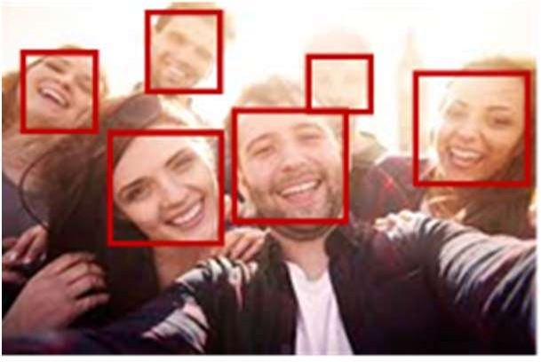

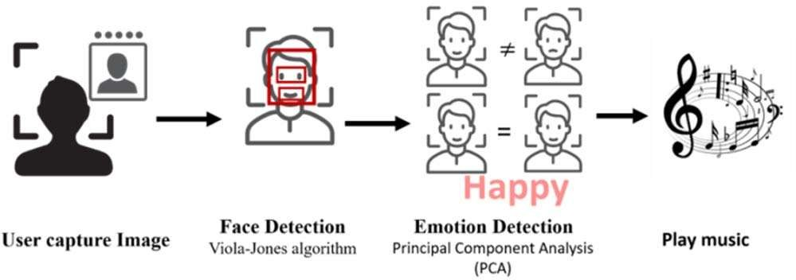

The Proposed System Architecture

Resource & Environment Needs

Testing Tools
1. Openface
2. Affective
3. Microsoft Azure Face API

Test Environment
- Well-lit room with consisting lightening conditions
- Camera capable of capturing high resolution images and videos of the face

Terms/Acronyms

TERM/ACRONYM | DEFINITION
API | Application Program Interface
AUT | Application Under Test

Ms Shreela Pareek Mr. Abhishek Goyal
(Project Guide) (Testing Lab Faculty)

Submitted by Submitted To:
Priyanshu singh (2000290120120) - 8B Prof. Neha Shukla
Rishika Tyagi (2000290120126) – 8B Project Coordinator
Ritika Rai (2100290129007 )– 8B Dept. of Computer Science

